Smart library Management System

Student Name: VAIBHAVI SONIGRA
Course / Subject: Smart Lidrary Management System
Database Platform: MySQL Engine (via phpMyAdmin)

1. Database banao
CREATE DATABASE smart_library;
USE smart_library;
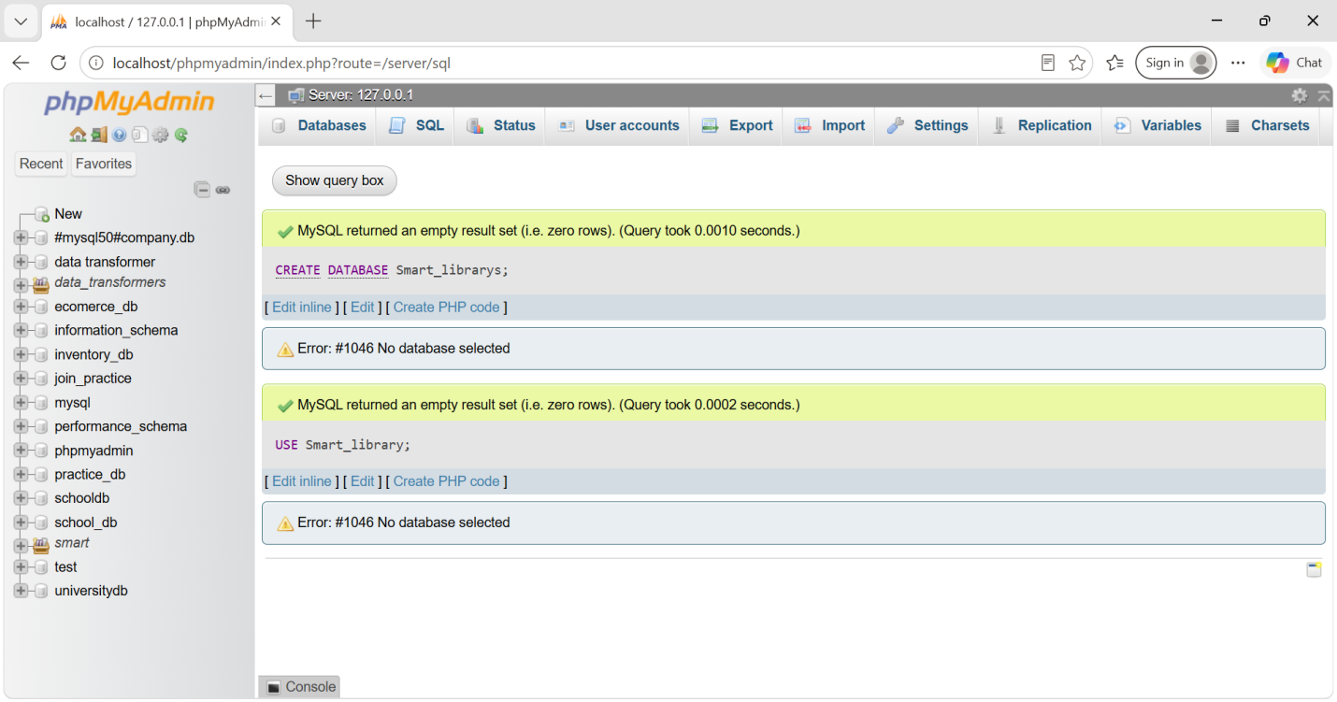2. 4 main tables banao
Authors
CREATE TABLE Authors (
author_id INT PRIMARY KEY AUTO_INCREMENT,
name VARCHAR(100) NOT NULL,
country VARCHAR(50)
);
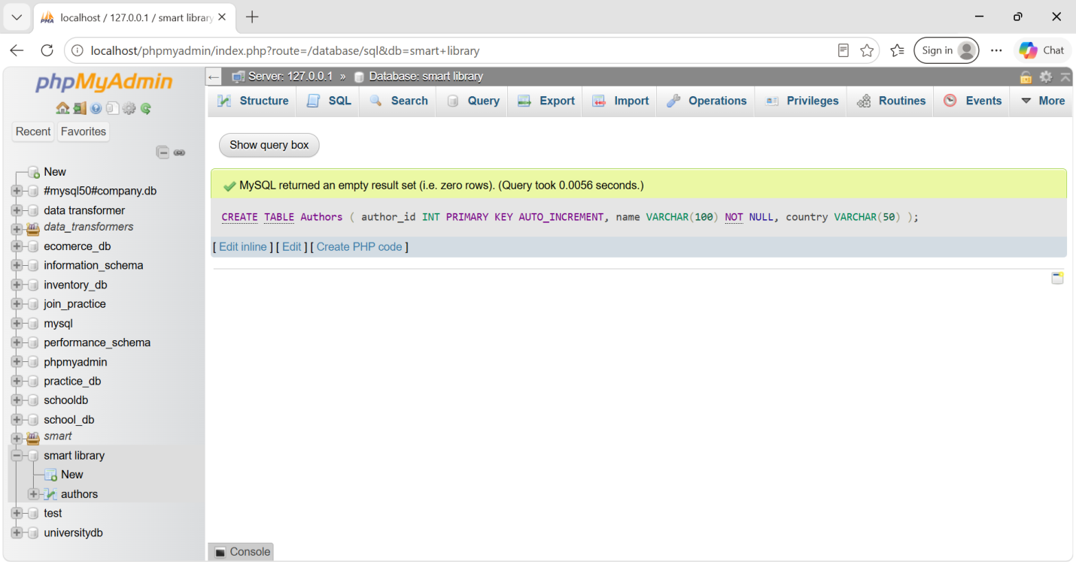
Books
CREATE TABLE Books (
book_id INT PRIMARY KEY AUTO_INCREMENT,
title VARCHAR(150) NOT NULL,
author_id INT,
category VARCHAR(50),
price DECIMAL(10,2),
published_date DATE,
available BOOLEAN DEFAULT TRUE,
FOREIGN KEY (author_id) REFERENCES Authors(author_id)
);
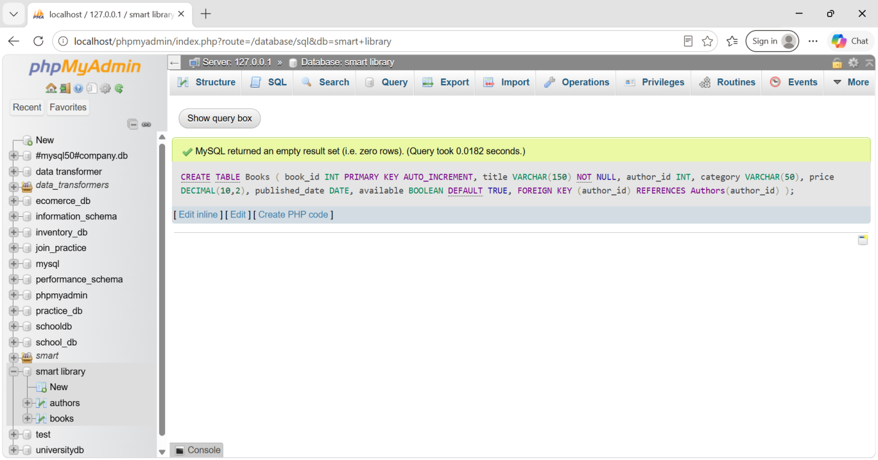
Members
CREATE TABLE Members (
member_id INT PRIMARY KEY AUTO_INCREMENT,
name VARCHAR(100) NOT NULL,
email VARCHAR(100),
phone_number VARCHAR(15),
membership_date DATE
);
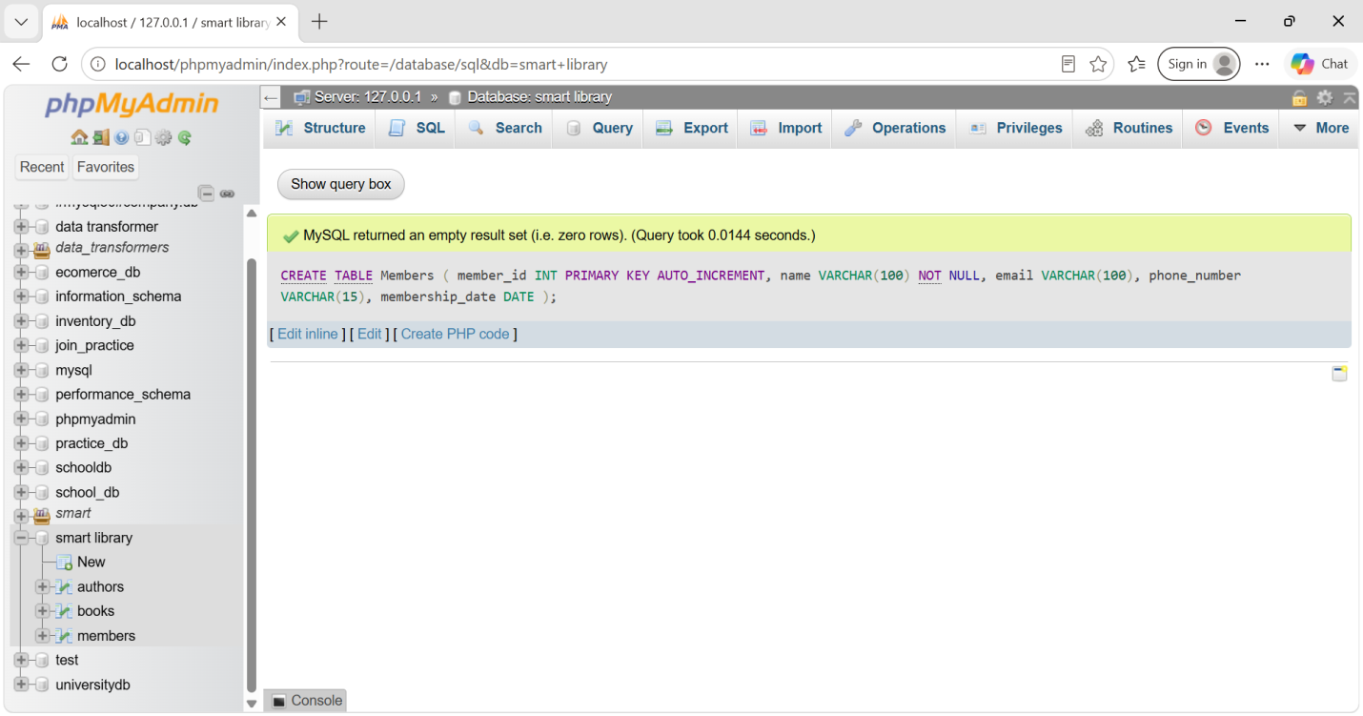

Transactions
CREATE TABLE Transactions (
transaction_id INT PRIMARY KEY AUTO_INCREMENT,
member_id INT,
book_id INT,
borrow_date DATE,
return_date DATE,
fine_amount DECIMAL(10,2),
FOREIGN KEY (member_id) REFERENCES Members(member_id),
FOREIGN KEY (book_id) REFERENCES Books(book_id)
);
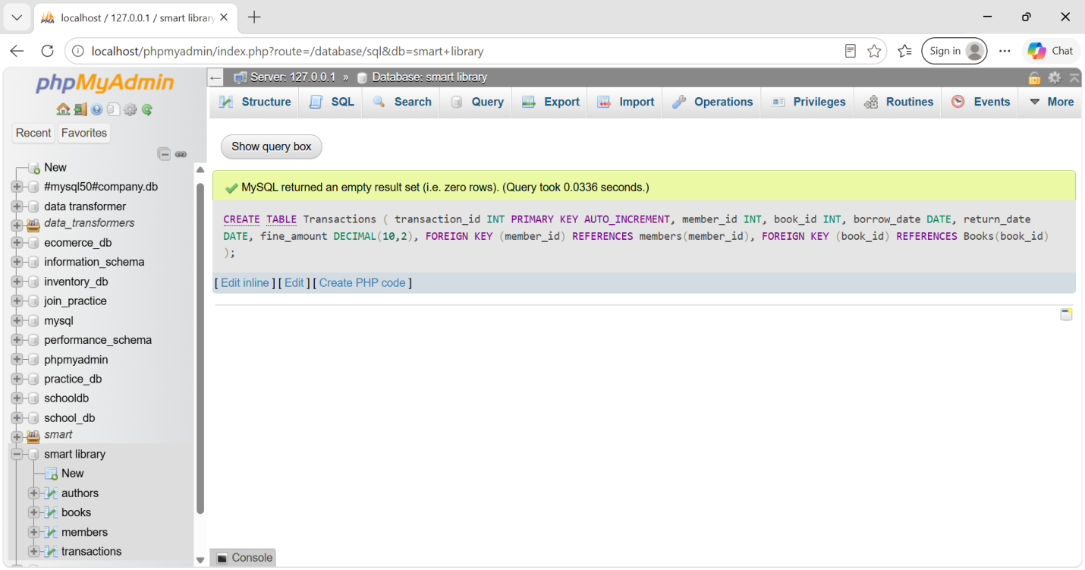

Step 1: Authors me data
NSERT INTO Authors (name, country) VALUES
('J.K. Rowling', 'United Kingdom'),
('George Orwell', 'United Kingdom'),
('Dan Brown', 'United States'),
('R.K. Narayan', 'India'),
('A.P.J. Abdul Kalam', 'India');
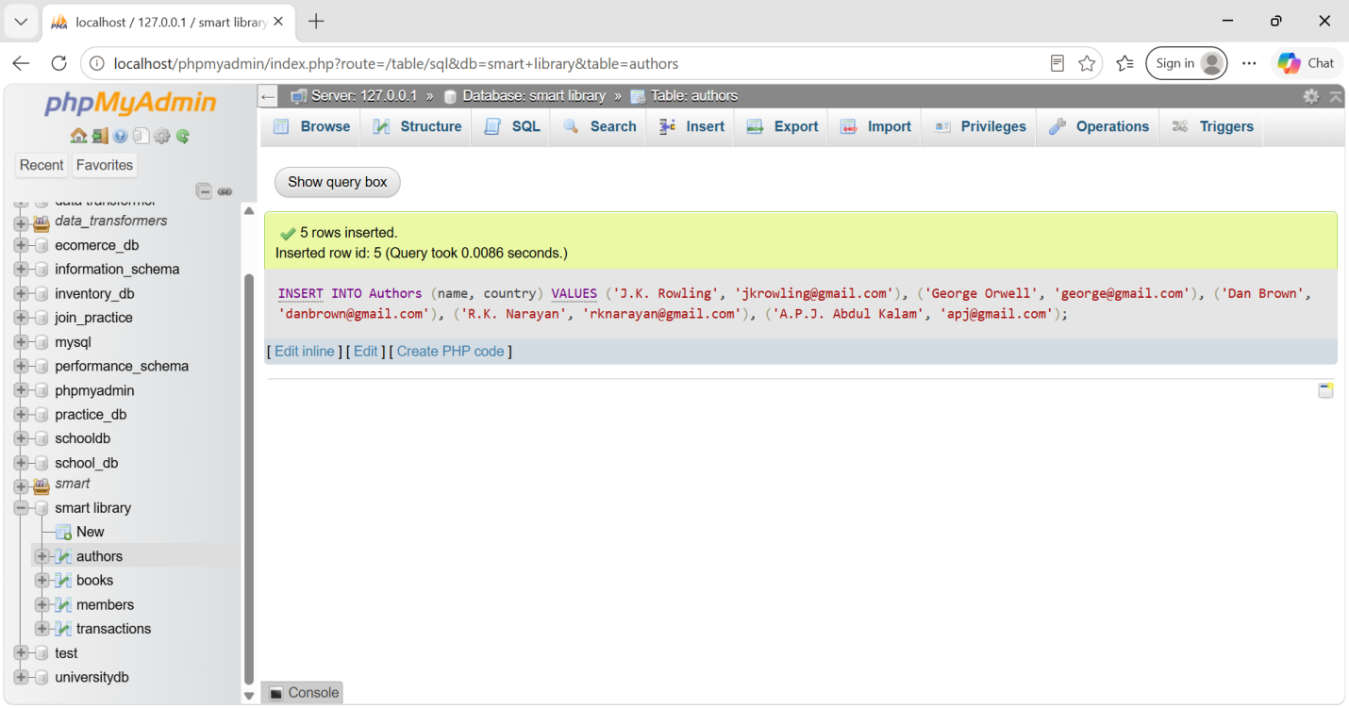

Step 2: Books me data

INSERT INTO Books
(title, author_id, category, price, published_date, available)
VALUES
('Harry Potter', 1, 'Fantasy', 450.00, '1997-06-26', TRUE),
('1984', 2, 'Science Fiction', 350.00, '1949-06-08', TRUE),
('The Da Vinci Code', 3, 'Thriller', 550.00, '2003-04-01', TRUE),
('Malgudi Days', 4, 'Fiction', 300.00, '1943-01-01', TRUE),
('Wings of Fire', 5, 'Biography', 400.00, '1999-01-01', TRUE);

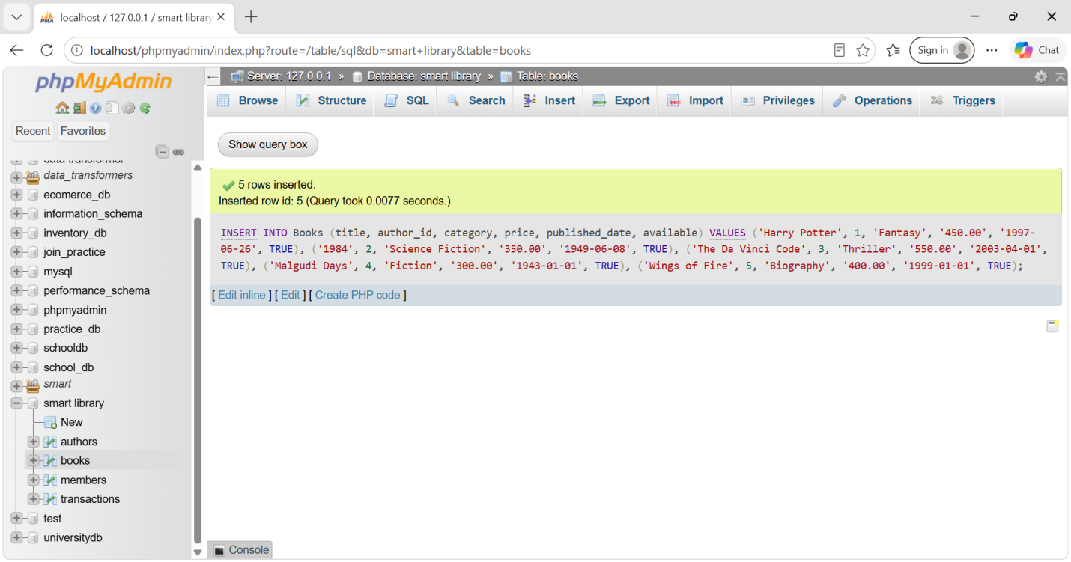 Step 3: Members me data
INSERT INTO Members
(name, email, phone_number, membership_date)
VALUES
('Rahul Sharma', 'rahul@gmail.com', '9876543210', '2021-05-10'),
('Priya Patel', 'priya@gmail.com', '9876543211', '2022-03-15'),
('Amit Shah', 'amit@gmail.com', '9876543212', '2023-01-20'),
('Neha Joshi', 'neha@gmail.com', '9876543213', '2020-11-05'),
('Karan Mehta', 'karan@gmail.com', '9876543214', '2023-06-12');

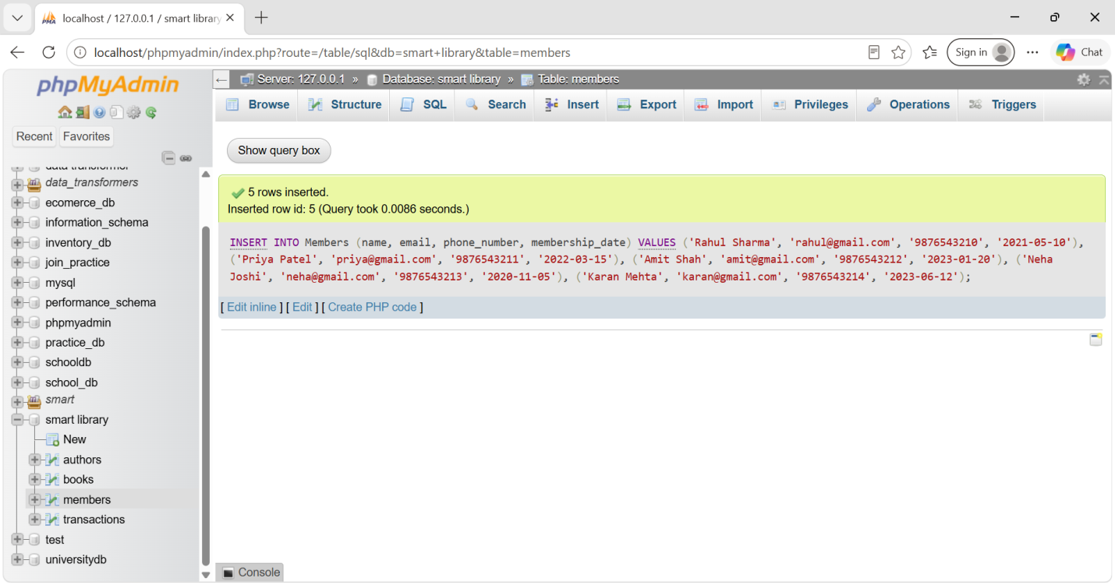 Step 4: Transactions me data
INSERT INTO Transactions
(member_id, book_id, borrow_date, return_date, fine_amount)
VALUES
(1, 1, '2024-01-10', '2024-01-20', 0),
(2, 2, '2024-02-05', '2024-02-18', 20),
(3, 3, '2024-03-12', '2024-03-25', 10),
(1, 4, '2024-04-01', '2024-04-10', 0),
(4, 5, '2024-05-15', '2024-05-30', 30),
(2, 1, '2024-06-05', '2024-06-15', 0),
(5, 3, '2024-07-10', '2024-07-25', 25);
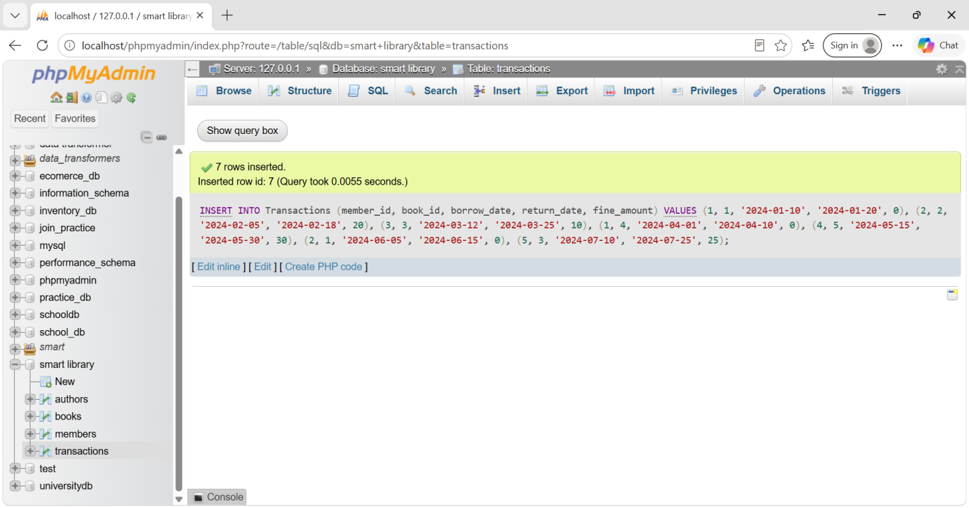

1. CRUD Operations

A. New Author insert
INSERT INTO Authors (name, country)
VALUES ('Chetan Bhagat', 'India');
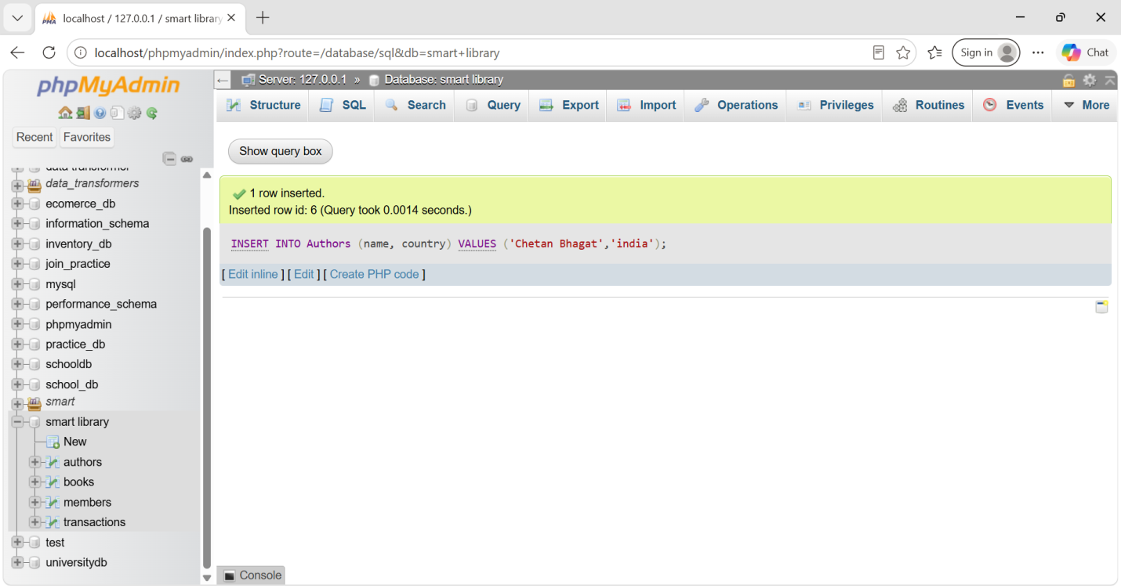

B. New Book insert
INSERT INTO Books
(title, author_id, category, price, published_date, available)
VALUES
('Five Point Someone', 6, 'Fiction', 350.00, '2004-05-01', TRUE);
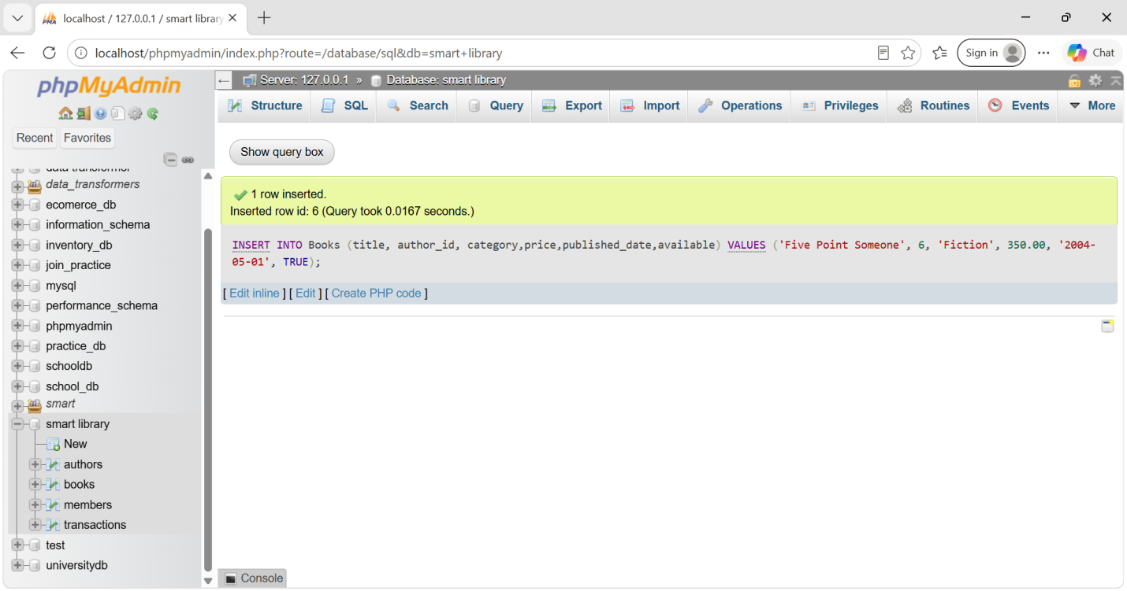

C. New Member insert
INSERT INTO Members
(name, email, phone_number, membership_date)
VALUES
('Rahul Patel', 'rahulpatel@gmail.com', '9876501234', '2024-01-15');
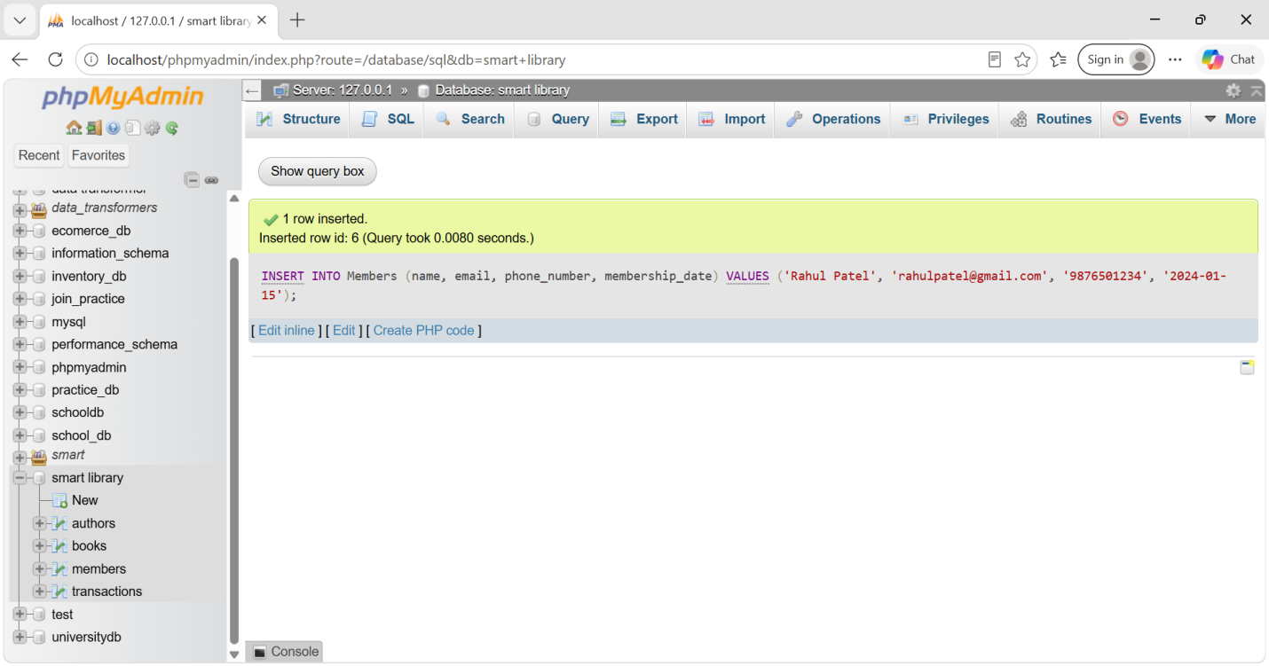

D. Book borrow hone par availability update
UPDATE Books
SET available = FALSE
WHERE book_id = 1;
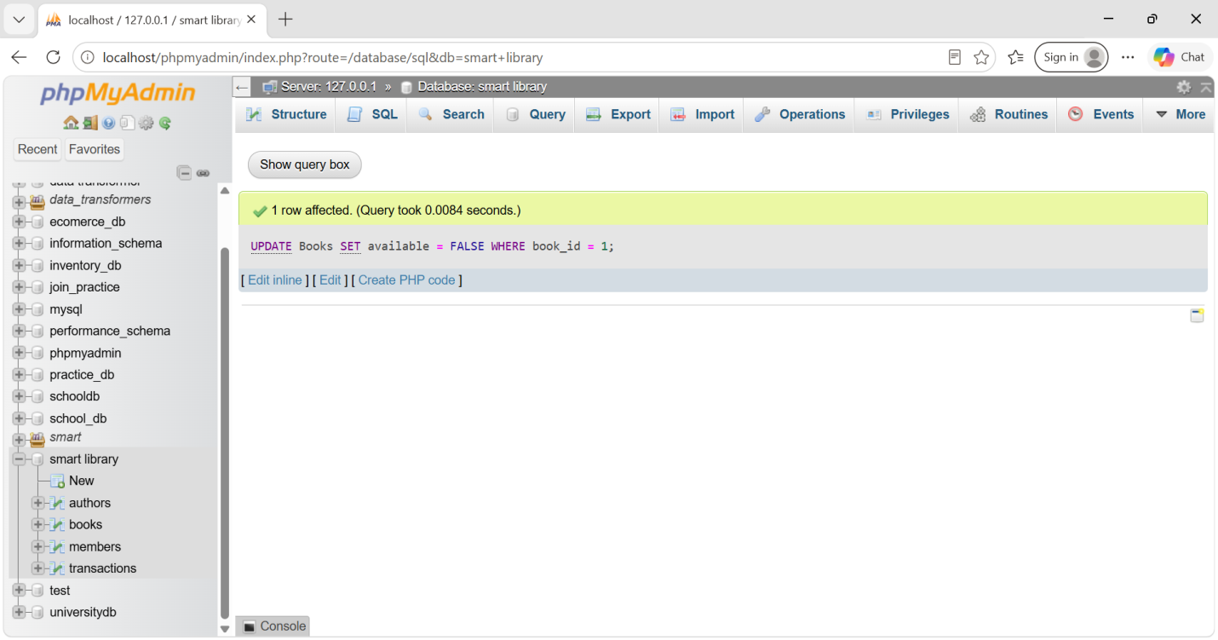

E. Book return hone par availability update
UPDATE Books
SET available = TRUE
WHERE book_id = 1;
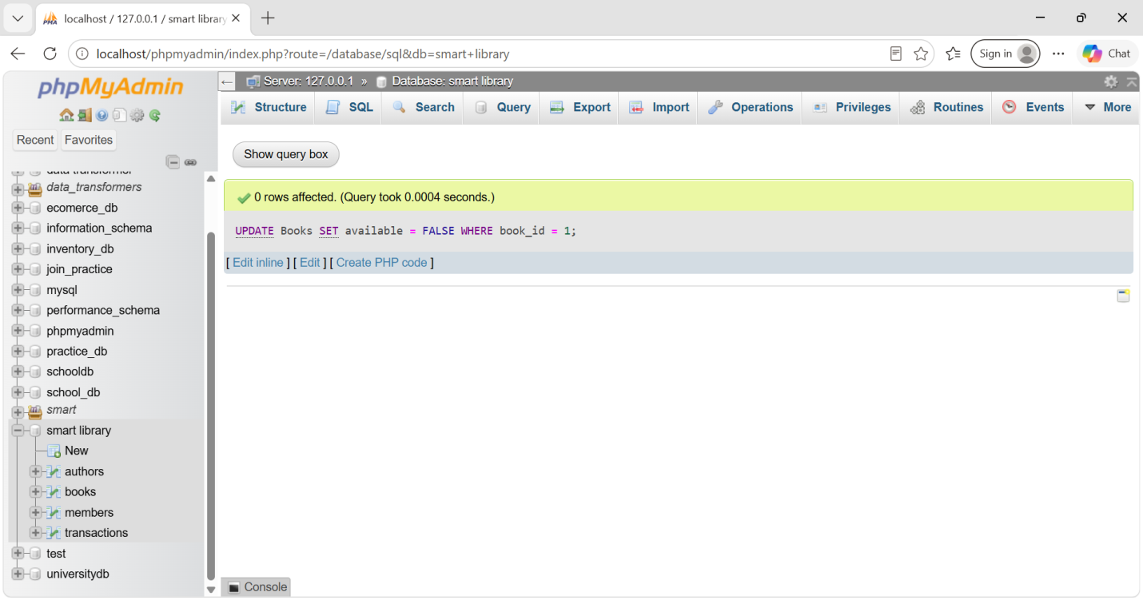

2. WHERE, HAVING, LIMIT

A. 2015 ke baad published books
SELECT *
FROM Books
WHERE published_date > '2015-12-31';
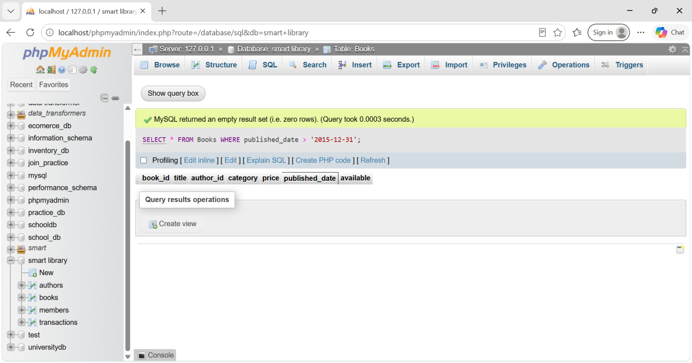

B. Top 5 most expensive books
SELECT *
FROM Books
ORDER BY price DESC
LIMIT 5;
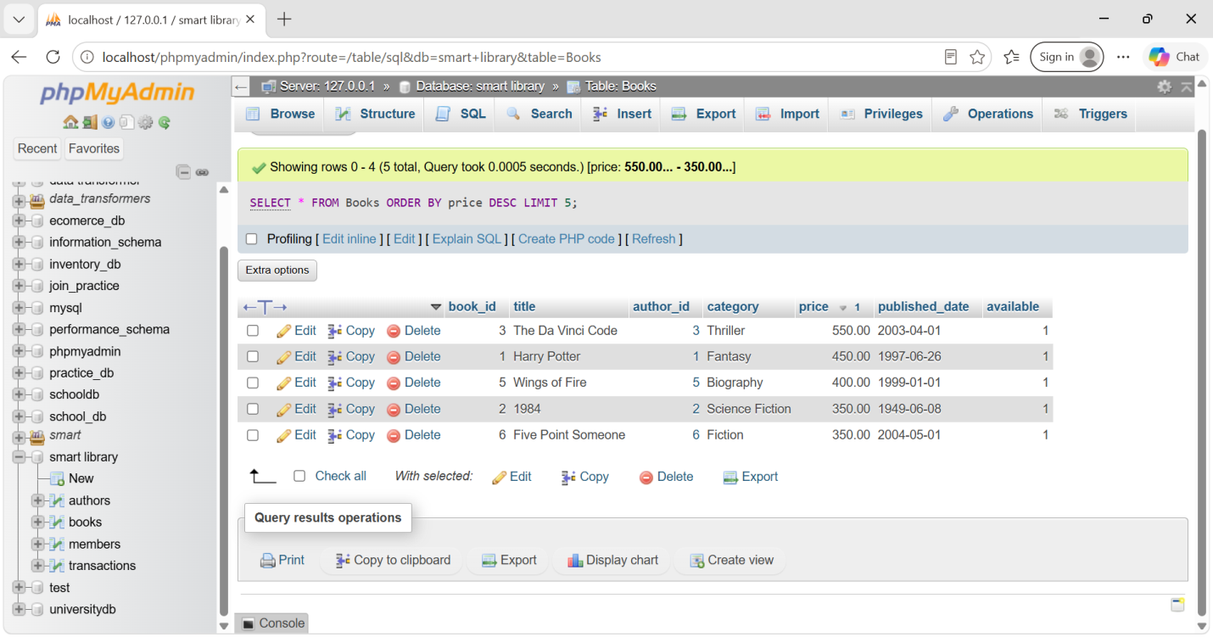

C. 2022 se pehle join hue members
SELECT *
FROM Members
WHERE membership_date < '2022-01-01';
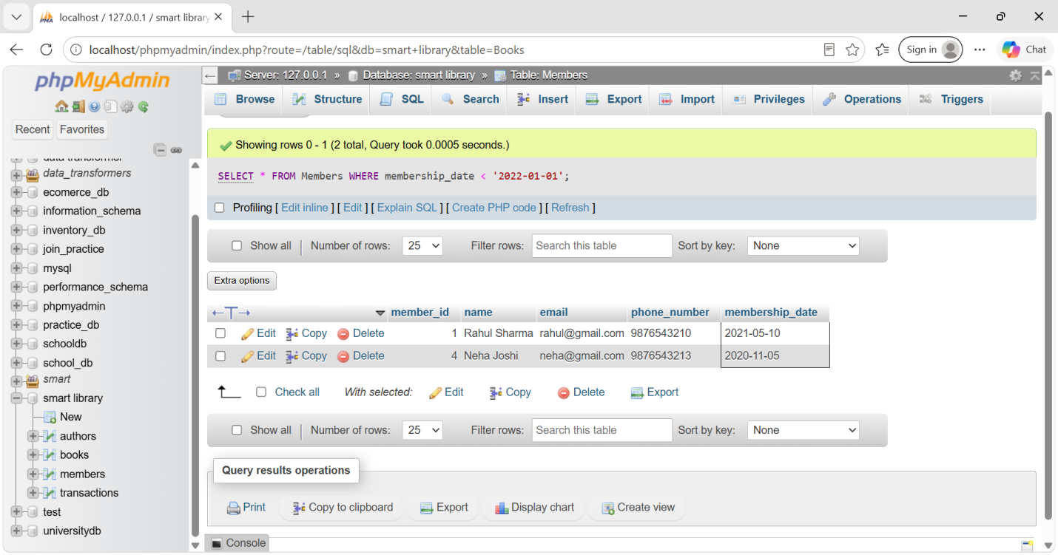

3. Apply SQL Operators — AND, OR, NOT
SELECT m.member_id, m.name, m.email, m.phone_number, m.membership_date
FROM Members m
LEFT JOIN Transactions t
ON m.member_id = t.member_id
GROUP BY m.member_id, m.name, m.email, m.phone_number, m.membership_date
HAVING YEAR(m.membership_date) > 2020
OR COUNT(t.transaction_id) > 3;

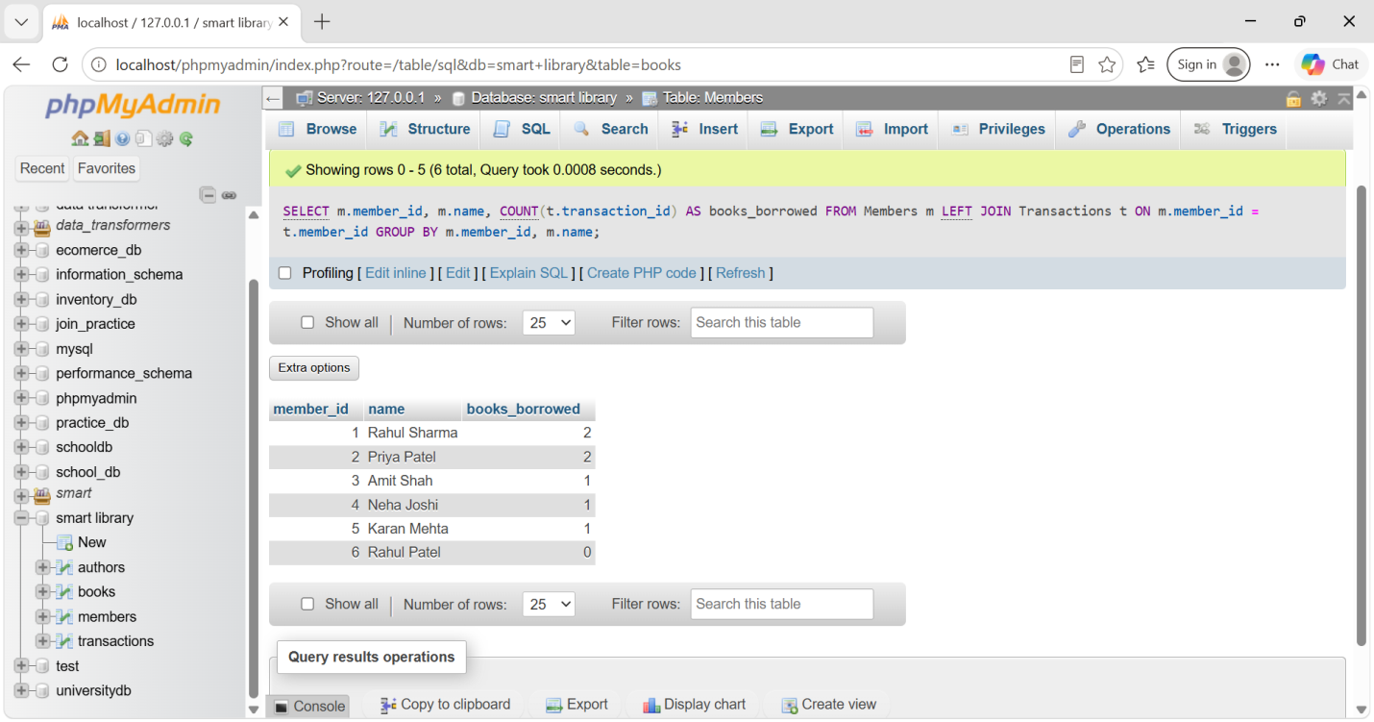 4. Sorting & Grouping Data

1. Books ko title ke alphabetical order me
SELECT *
FROM Books
ORDER BY title ASC;
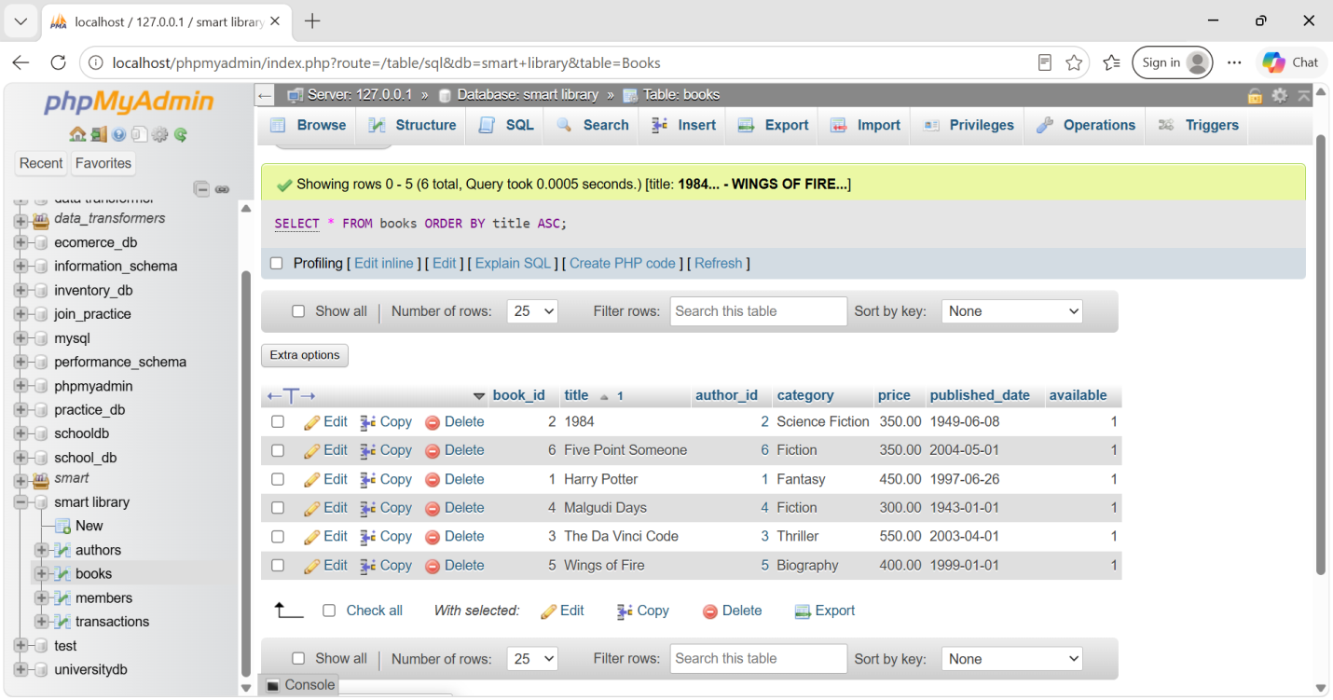

2. Har member ne kitni books borrow ki
SELECT
m.member_id,
m.name,
COUNT(t.transaction_id) AS books_borrowed
FROM Members m
LEFT JOIN Transactions t
ON m.member_id = t.member_id
GROUP BY m.member_id, m.name;

3. Category-wise books ka total count
SELECT
category,
COUNT(*) AS total_books
FROM Books
GROUP BY category;
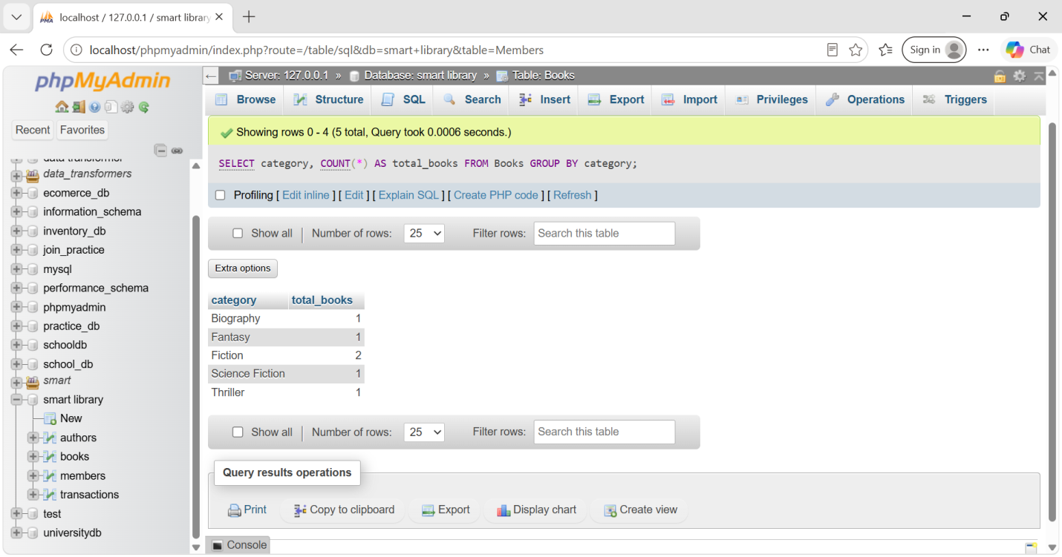

5. Aggregate Functions

1. Each category me total books
SELECT
category,
COUNT(*) AS total_books
FROM Books
GROUP BY category;
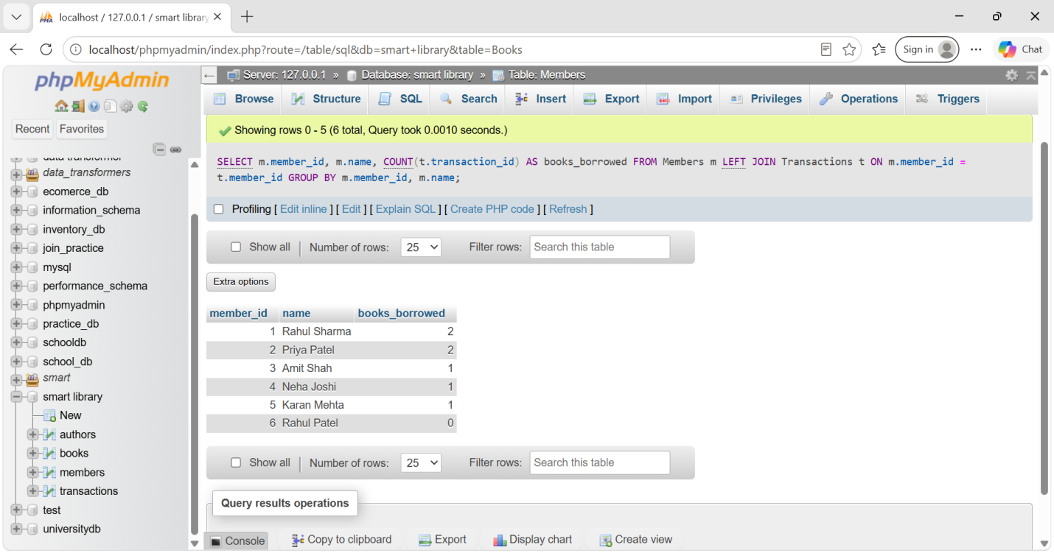

2. Total book price
SELECT SUM(price) AS total_price
FROM Books;
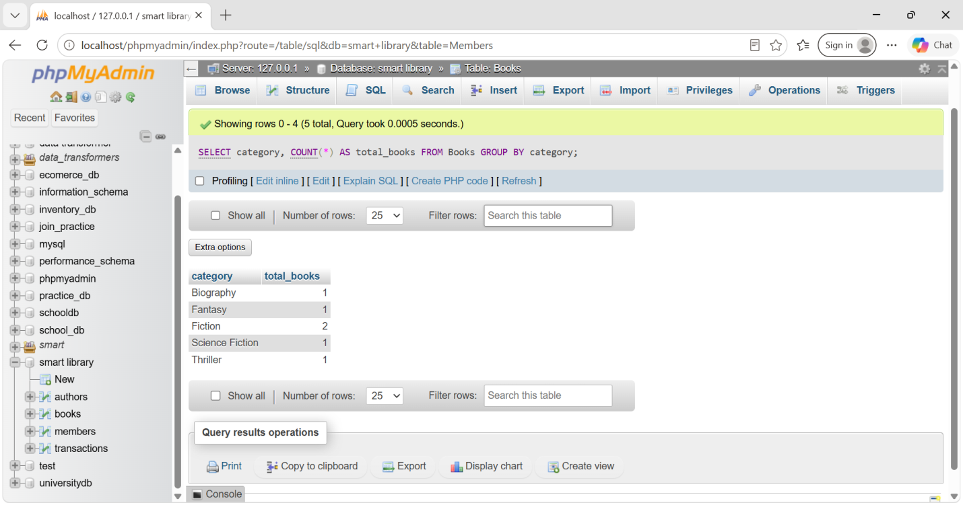

3. Average book price
SELECT AVG(price) AS average_price
FROM Books;
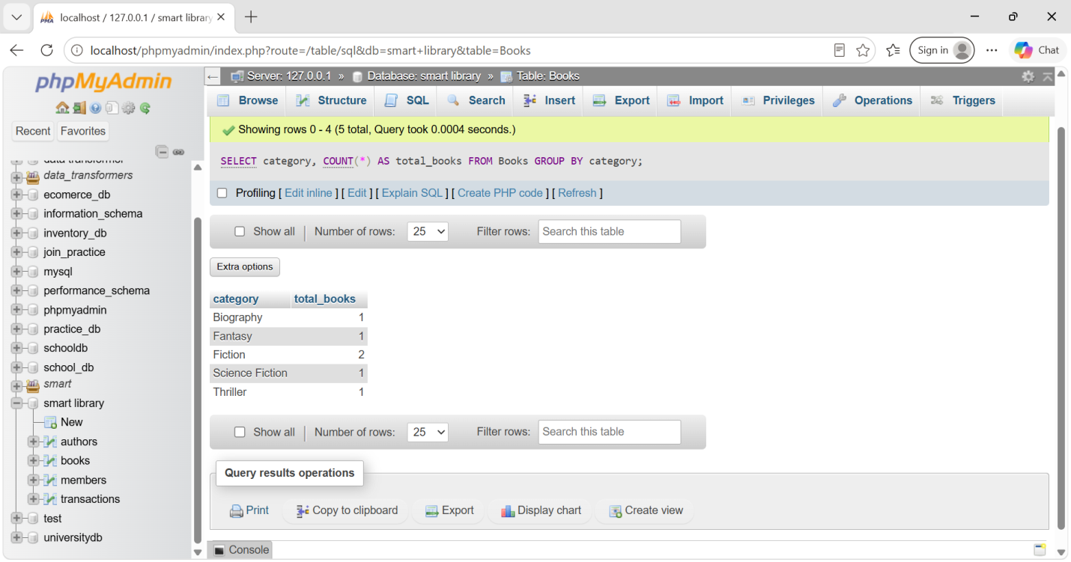

4. Most expensive book price
SELECT MAX(price) AS highest_price
FROM Books;
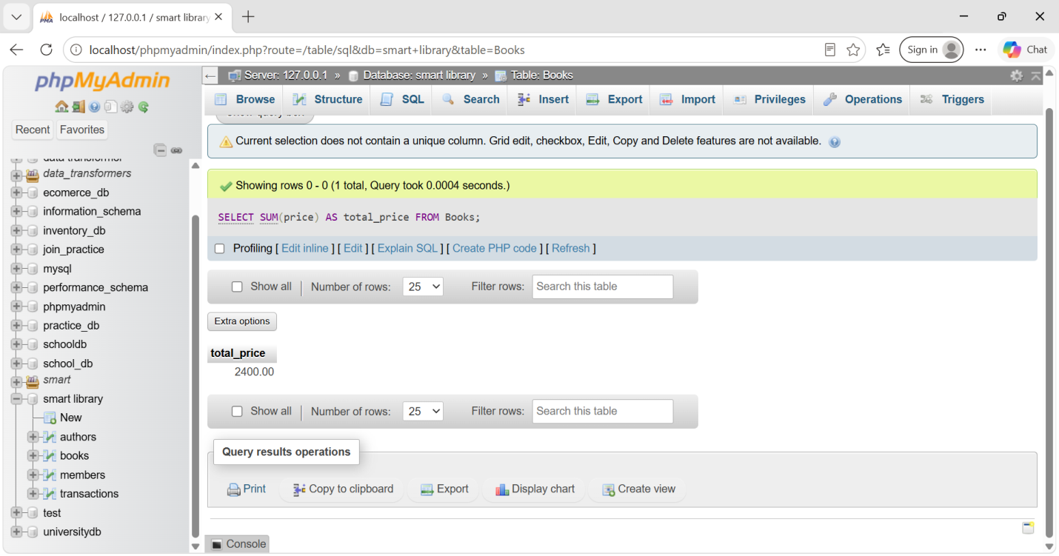

5. Cheapest book price
SELECT MIN(price) AS lowest_price
FROM Books;
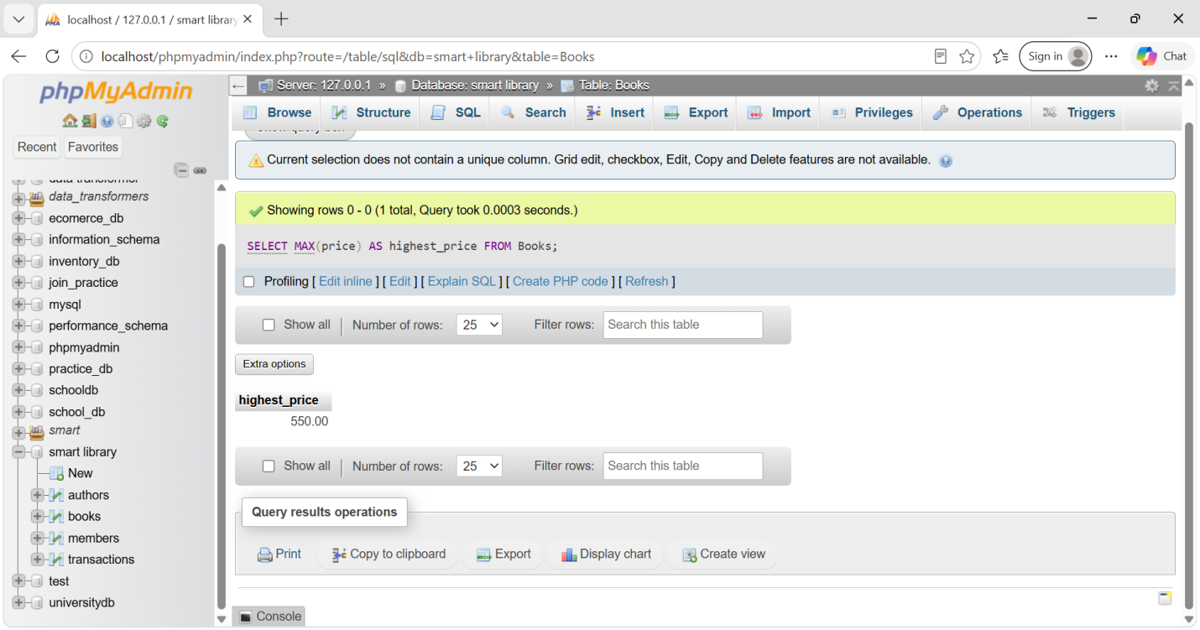

6. Total number of books
SELECT COUNT(*) AS total_books
FROM Books;
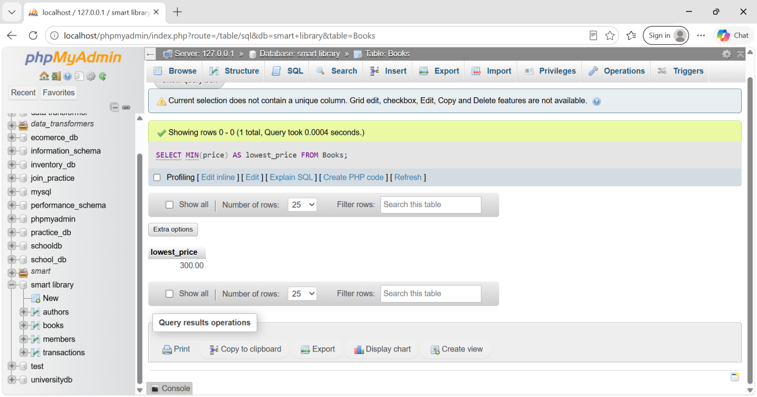

7. Implement JOINs

7.1 Books + Author names — INNER JOIN
SELECT
b.book_id,
b.title,
a.name AS author_name
FROM Books b
INNER JOIN Authors a
ON b.author_id = a.author_id;
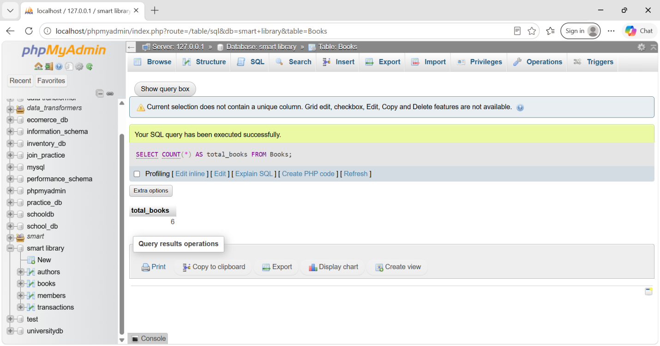

7.2 Members who have borrowed books — LEFT JOIN
SELECT
m.member_id,
m.name,
t.book_id,
t.borrow_date,
t.return_date
FROM Members m
LEFT JOIN Transactions t
ON m.member_id = t.member_id
WHERE t.transaction_id IS NOT NULL;
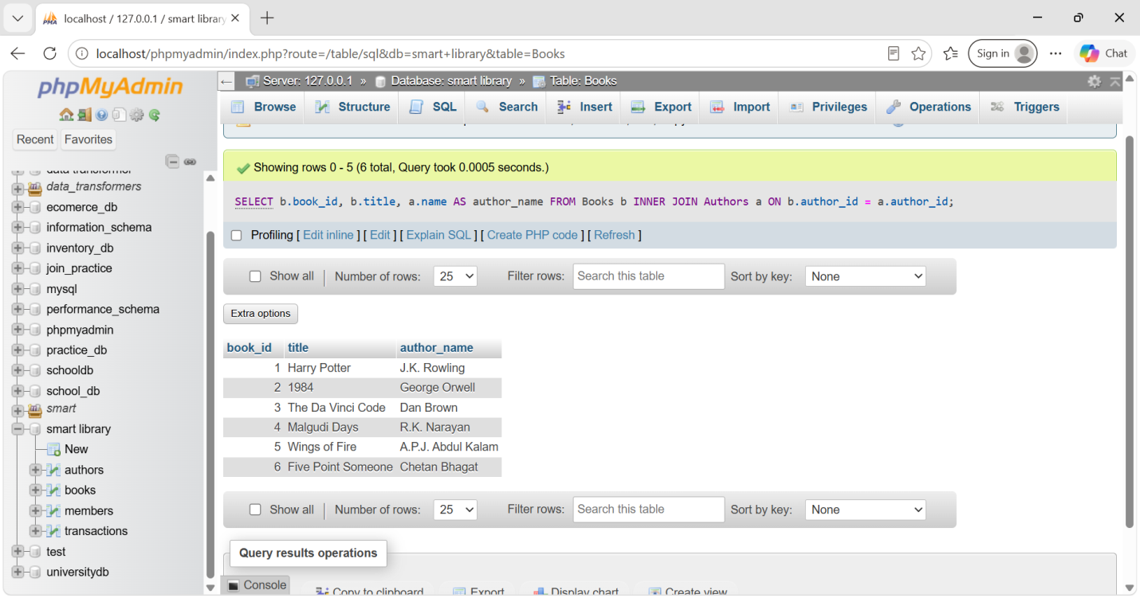

7.3 Books that haven't been borrowed — RIGHT JOIN
SELECT
b.book_id,
b.title
FROM Transactions t
RIGHT JOIN Books b
ON t.book_id = b.book_id
WHERE t.transaction_id IS NULL;
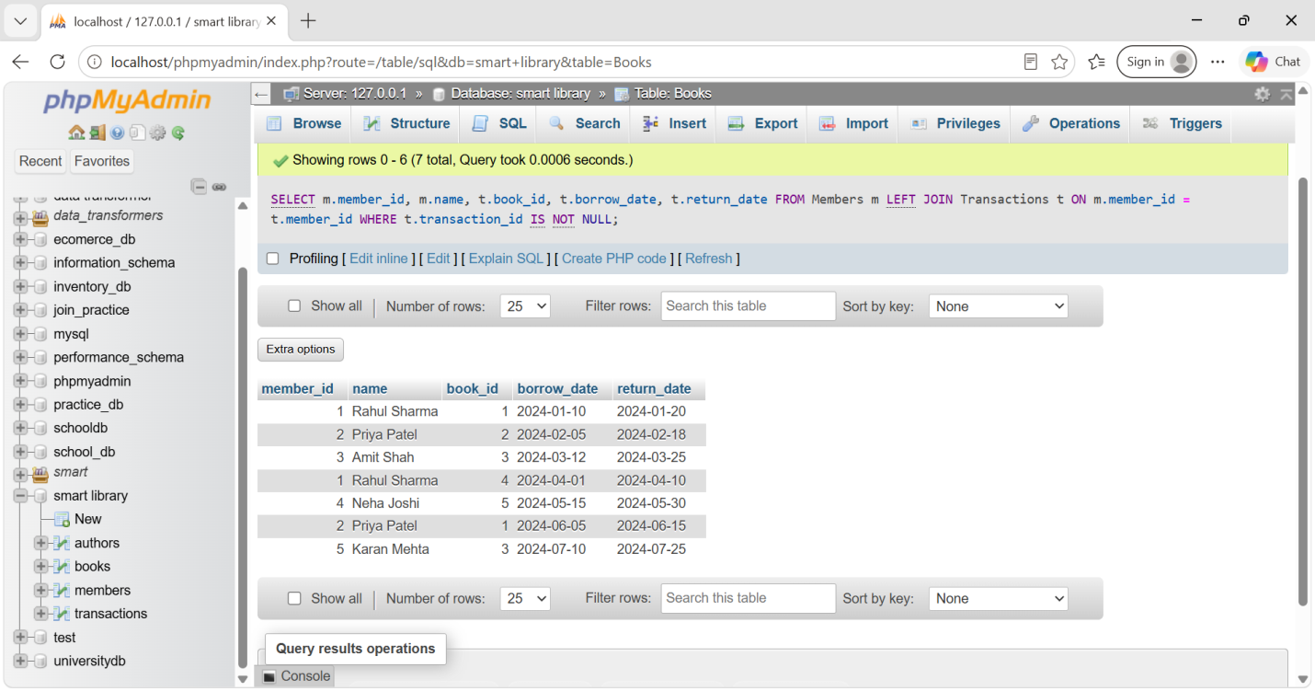

7.4 Members who have never borrowed a book — FULL OUTER JOIN
MySQL me direct FULL OUTER JOIN nahi hota, isliye UNION use karenge:
SELECT
m.member_id,
m.name,
t.transaction_id
FROM Members m
LEFT JOIN Transactions t
ON m.member_id = t.member_id;
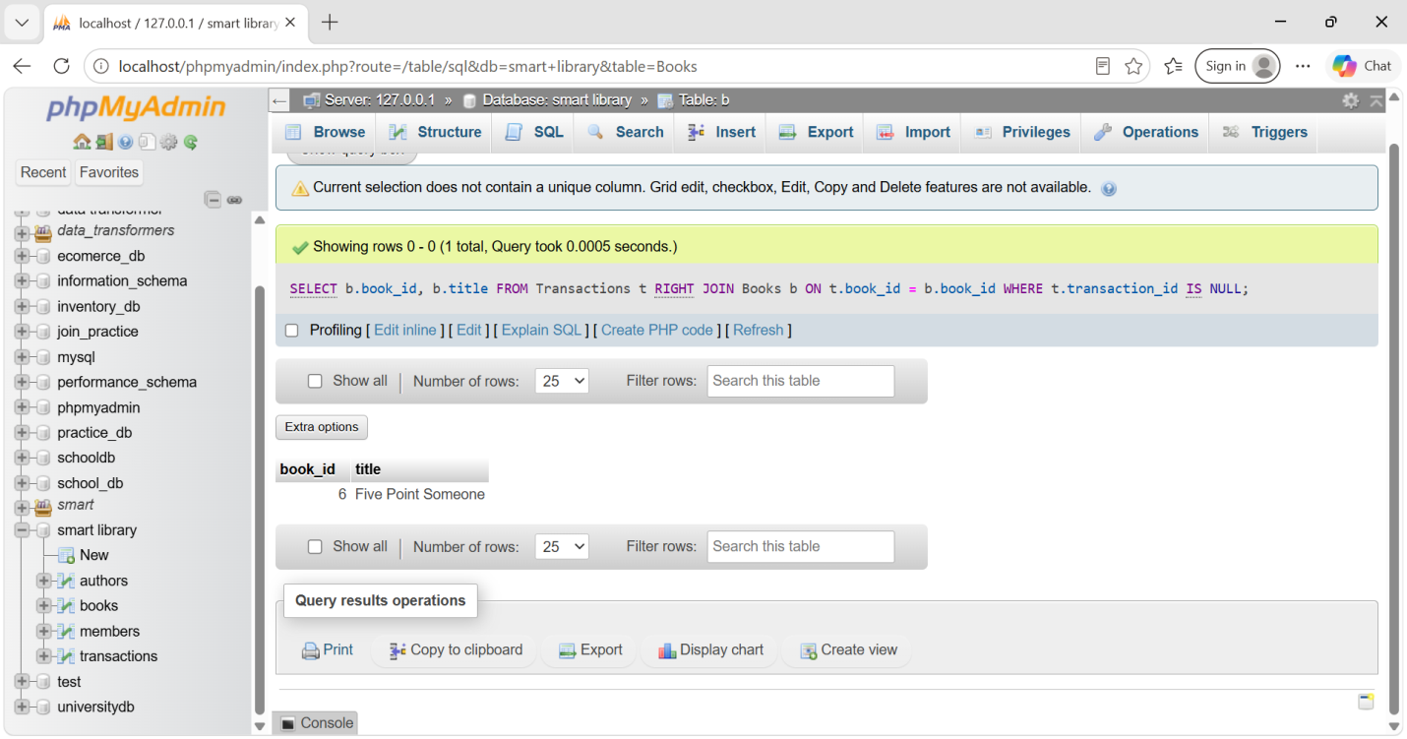

8. Use Subqueries

8.1 Books borrowed by members registered after 2022
SELECT *
FROM Books
WHERE book_id IN (
SELECT book_id
FROM Transactions
WHERE member_id IN (
SELECT member_id
FROM Members
WHERE membership_date > '2022-12-31'
)
);
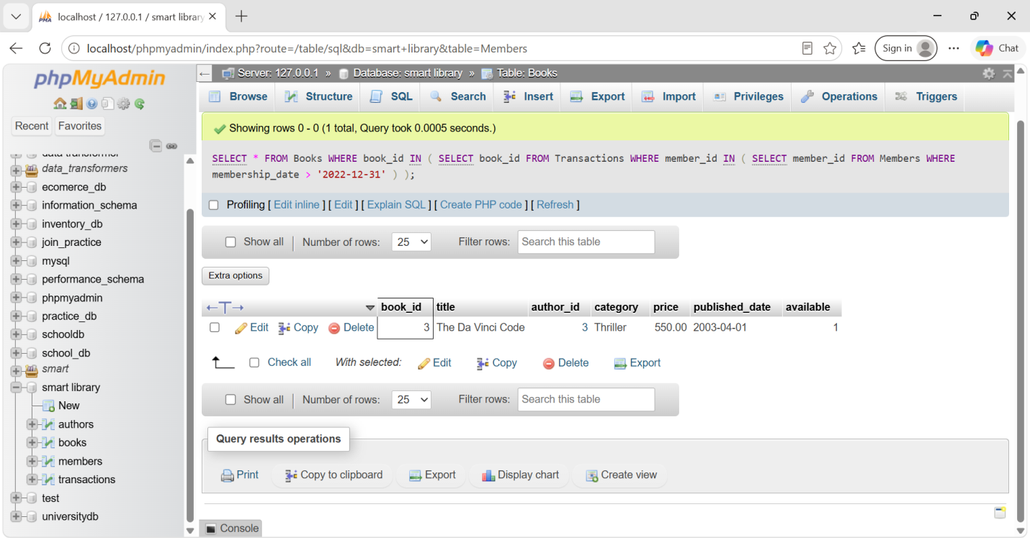

8.3 Members who have never borrowed a book
SELECT *
FROM Members
WHERE member_id NOT IN (
SELECT DISTINCT member_id
FROM Transactions
);
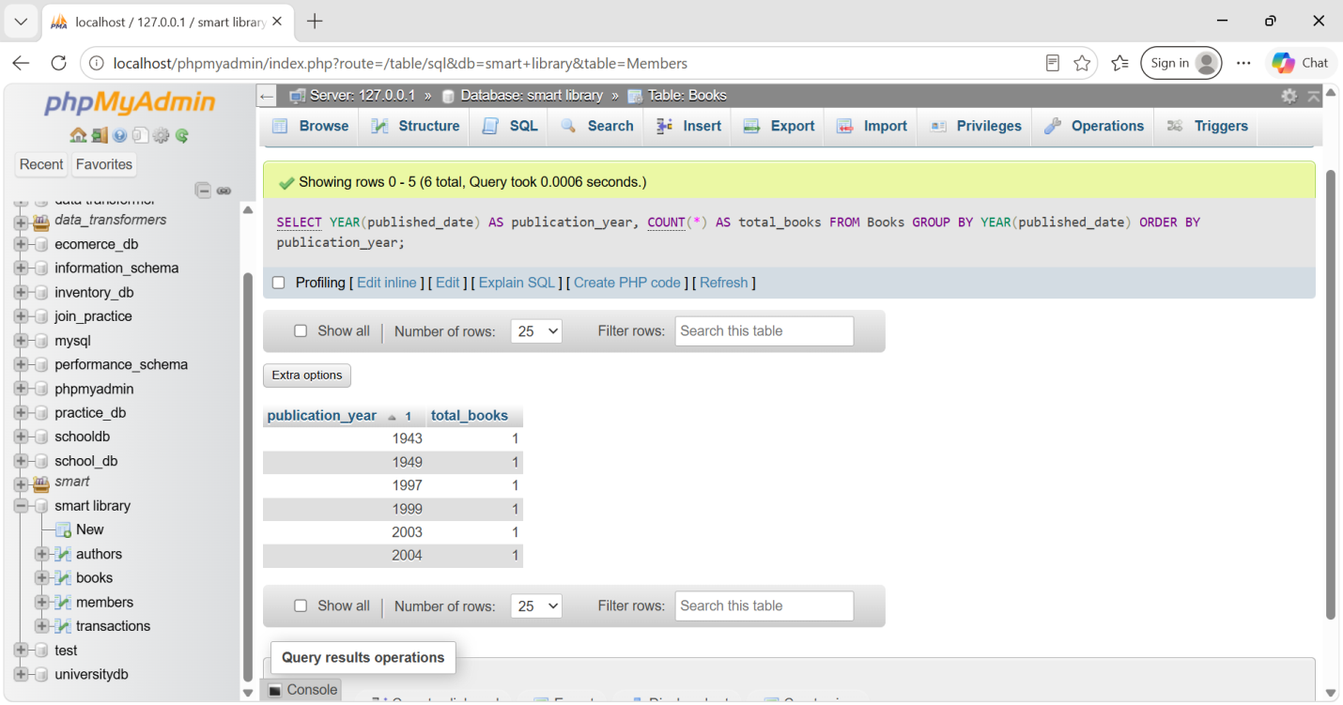

9. Date & Time Functions

9.1 Publication year ke according books count
SELECT
YEAR(published_date) AS publication_year,
COUNT(*) AS total_books
FROM Books
GROUP BY YEAR(published_date)
ORDER BY publication_year;
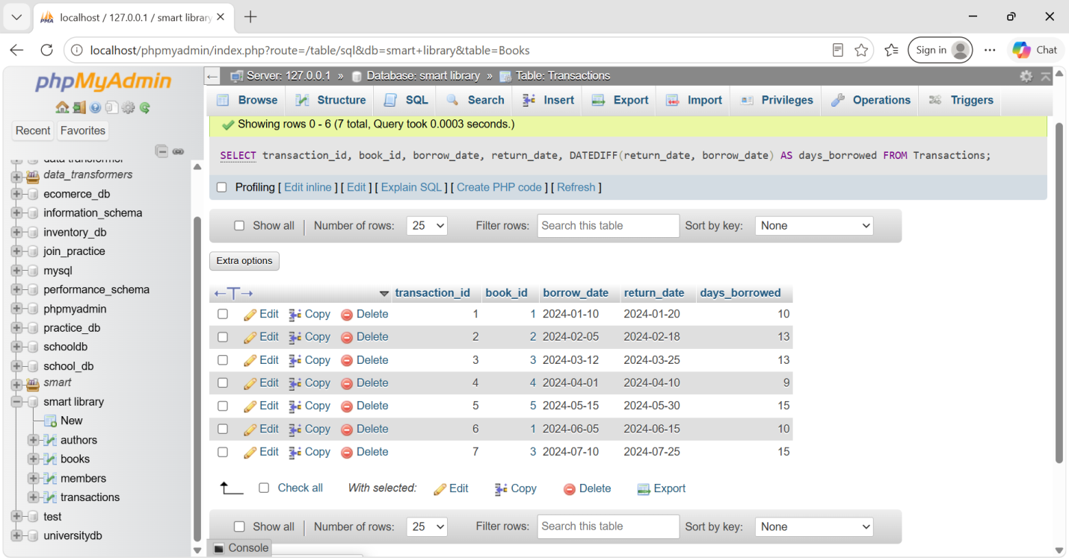

9.2 Borrow aur return ke beech days
SELECT
transaction_id,
book_id,
borrow_date,
return_date,
DATEDIFF(return_date, borrow_date) AS days_borrowed
FROM Transactions;
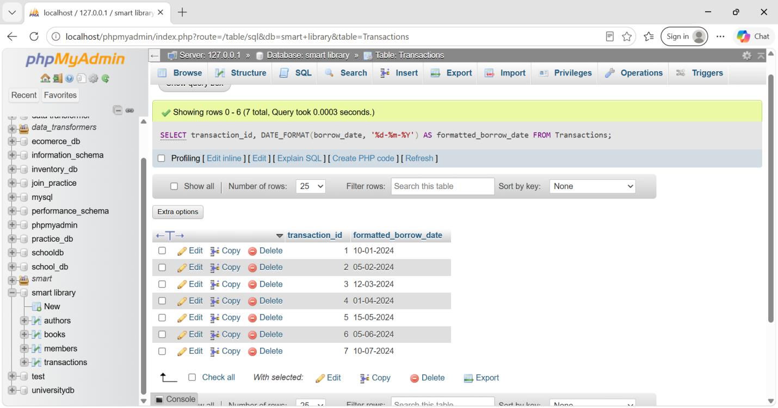

9.3 Borrow date ko DD-MM-YYYY format me
SELECT
transaction_id,
DATE_FORMAT(borrow_date, '%d-%m-%Y') AS formatted_borrow_date
FROM Transactions;
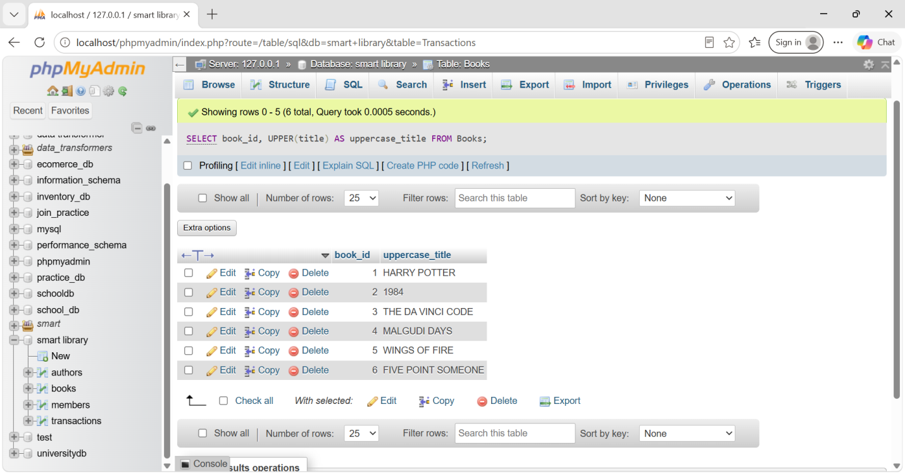

10. String Manipulation Functions

10.1 Book titles UPPERCASE
SELECT
book_id,
UPPER(title) AS uppercase_title
FROM Books;

10.2 Author names se extra spaces remove
SELECT
author_id,
TRIM(name) AS trimmed_author_name
FROM Authors;
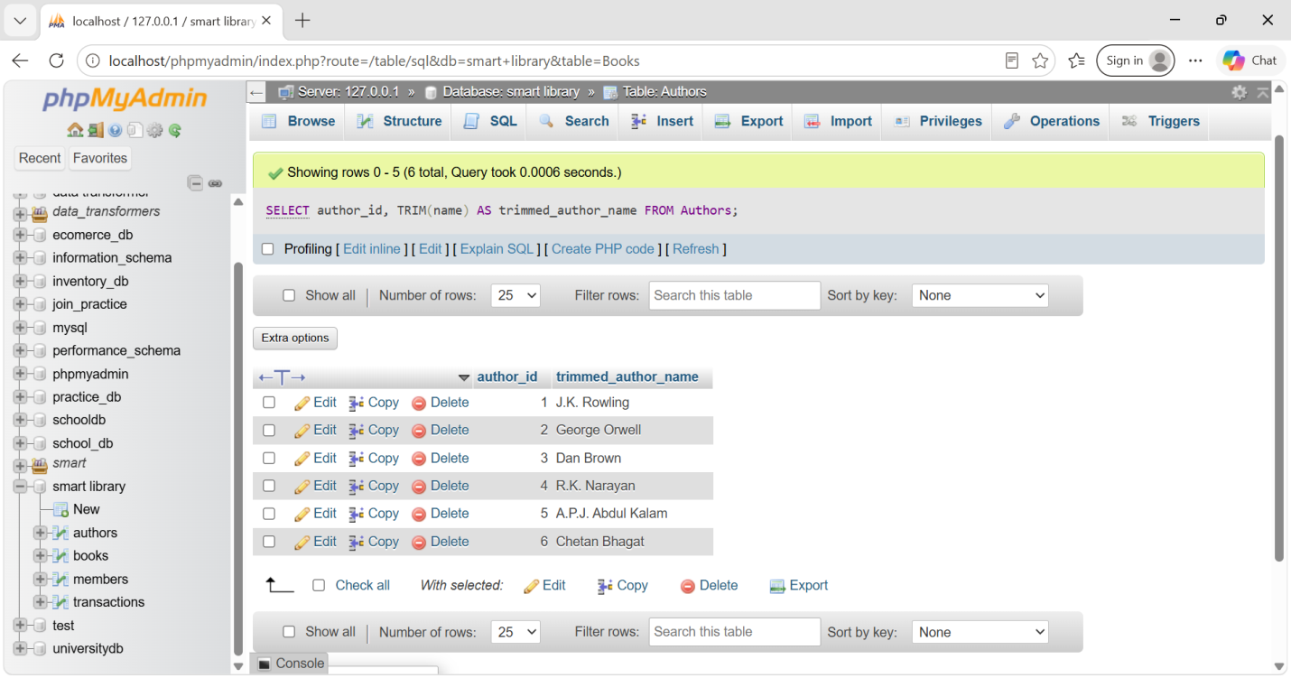

10.3 Missing email ko "Not Provided" dikhana
SELECT
member_id,
name,
COALESCE(email, 'Not Provided') AS email
FROM Members;
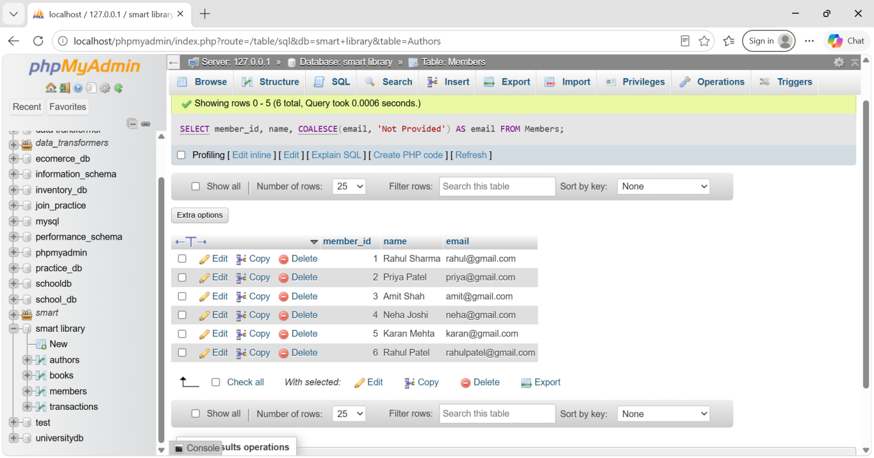

11. Window Functions

11.1 Books ko borrow count ke basis par rank karna
SELECT
b.book_id,
b.title,
COUNT(t.transaction_id) AS borrow_count,
RANK() OVER (
ORDER BY COUNT(t.transaction_id) DESC
) AS book_rank
FROM Books b
LEFT JOIN Transactions t
ON b.book_id = t.book_id
GROUP BY b.book_id, b.title;
_id
ORDER BY t.borrow_date
ROWS BETWEEN UNBOUNDED PRECEDING AND CURRENT ROW
) AS cumulative_books_borrowed
FROM Members m
JOIN Transactions t
ON m.member_id = t.member_id;
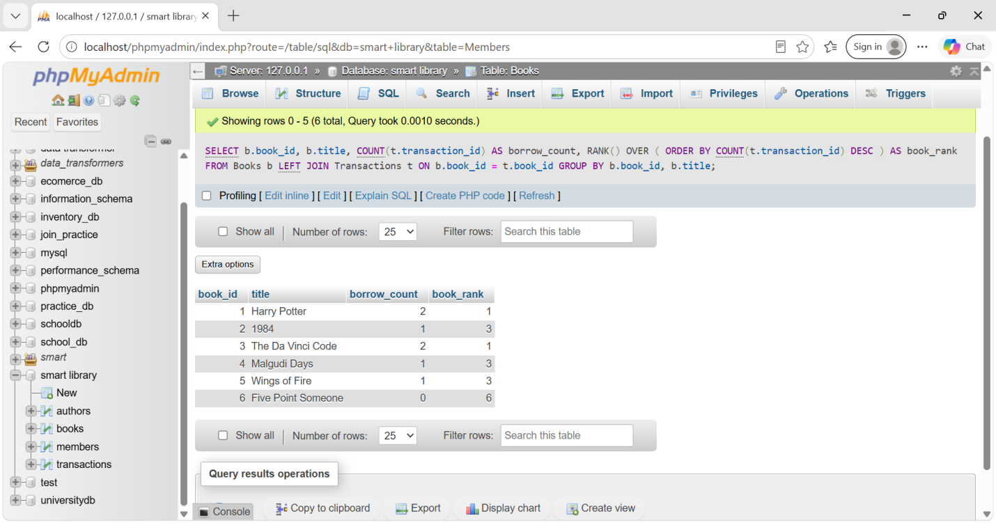

12. SQL CASE Expressions

12.1 Membership Status
SELECT
m.member_id,
m.name,
CASE
WHEN MAX(t.borrow_date) >= CURDATE() - INTERVAL 6 MONTH
THEN 'Active'
ELSE 'Inactive'
END AS Membership_Status
FROM Members m
LEFT JOIN Transactions t
ON m.member_id = t.member_id
GROUP BY m.member_id, m.name;
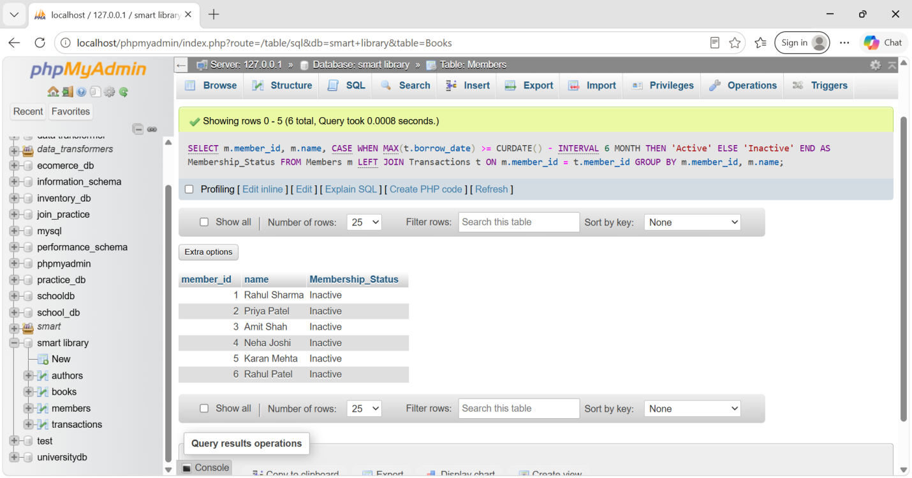

12.2 Books ko New Arrival / Classic / Regular categorize karna
SELECT
book_id,
title,
published_date,
CASE
WHEN YEAR(published_date) > 2020
THEN 'New Arrival'
WHEN YEAR(published_date) < 2000
THEN 'Classic'
ELSE 'Regular'
END AS book_type
FROM Books;
